**1. Basic Understanding of Master Layout**

* **Question 1**: What is a master layout in Laravel, and why is it used?  
  *Expected Answer*: A master layout in Laravel is a template file that contains the common structure for a web page, such as headers, footers, and sidebars. It is used to avoid repetitive code and maintain consistency across the pages by defining common elements once.
* **Question 2**: Where should the master layout file be placed in a typical Laravel application?  
  *Expected Answer*: The master layout file is typically placed in the resources/views/layouts directory.

**2. Creating and Extending Master Layout**

* **Question 3:** Create a basic master layout that includes a header, footer, and a main content section.

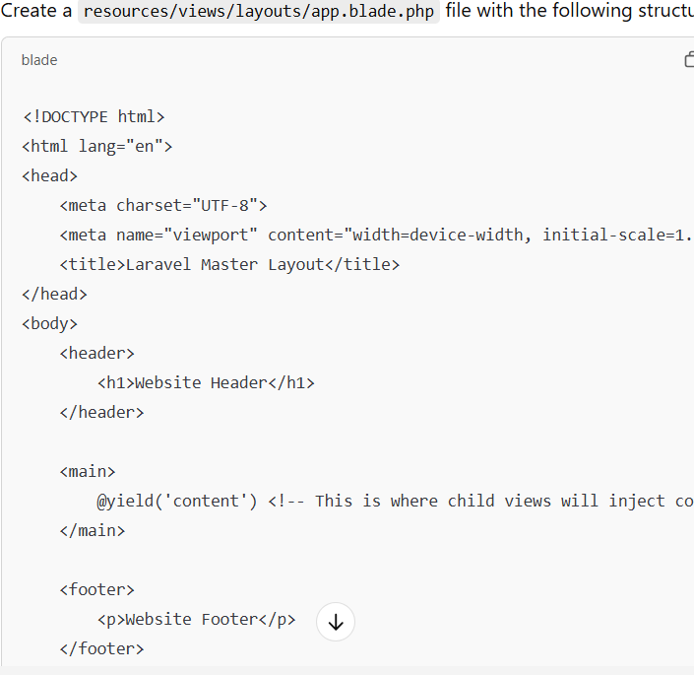

**Question 4**: How would you extend this master layout in a child view, and insert content in the @yield('content') section?

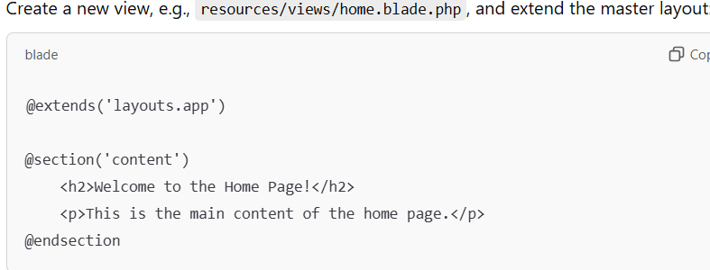

3. **Including Partial Views**

**Question 5**: How can you include a sidebar or a navigation menu in the master layout, and use it in a child view?

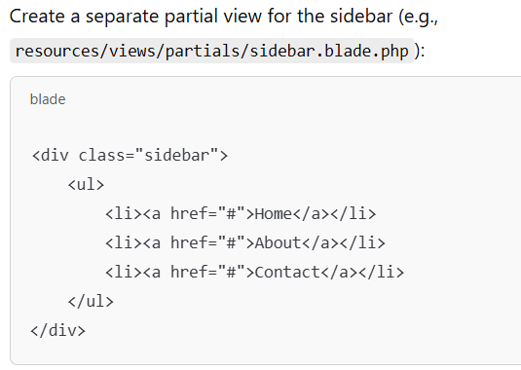

Then, include this sidebar in the master layout:

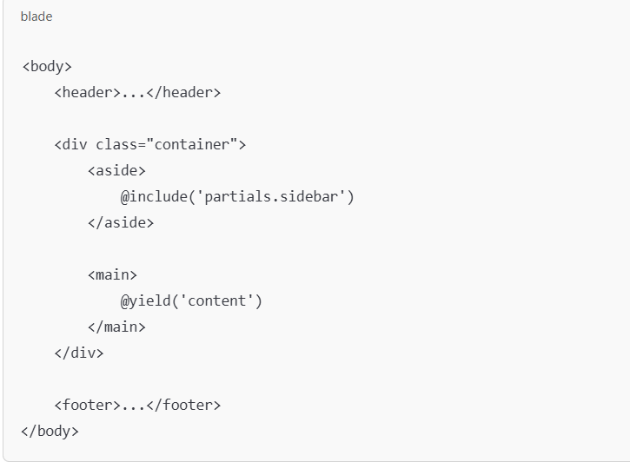

4. **Dynamic Content in Master Layout**

**Question 6**: How would you pass dynamic data (e.g., site title or user name) to the master layout from a controller?

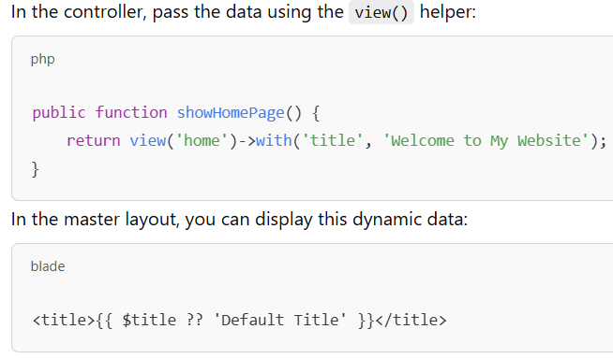

**1. Laravel Breeze Setup**

**Question 1**:  
You have installed Laravel and then Breeze. What are the necessary steps you would follow to fully set up Breeze, including authentication, and ensure the registration and login functionalities work?

*Expected Tasks:*

* Install Laravel via Composer.
* Install Breeze with composer require laravel/breeze --dev.
* Run php artisan breeze:install to install Breeze.
* Install NPM dependencies and build assets with npm install and npm run dev.
* Run migrations using php artisan migrate.

**2. Modifying Registration Form**

**Question 2**:  
Modify the default registration form to include a "Phone Number" field. After adding the field, ensure that the phone number is validated before registration.

*Expected Tasks:*

* Add a "phone" input field in resources/views/auth/register.blade.php.
* Modify app/Http/Controllers/Auth/RegisteredUserController.php to include the phone number in the validation and storage logic.
* Add validation for the phone number field in RegisteredUserController.

**3. Adding Custom Validation to Registration**

**Question 3**:  
You want to ensure that the password entered during registration is at least 8 characters long and contains both numbers and letters. Modify the registration logic to enforce this rule.

*Expected Tasks:*

* Modify the validation rules in RegisteredUserController.php.
* Add a custom validation rule to check for the password complexity.

$request->validate([

'password' => ['required', 'string', 'min:8', 'confirmed', 'regex:/[a-zA-Z]/', 'regex:/[0-9]/'],

]);